The CRCE Newsletter
No. 37 Spring/Summer 2010

57 Tufton Street, London SW1P 3QL Tel/fax: +44 (0) 20 7233 1050
email: crce@trident-net.co.uk website: www.crce.org.uk

Ljubo Sirc’s 90th Birthday
Bernard Brscic reports:
“Everything went extremely well. Ljubo was in good form and enjoyed the company of 50 guests. The main event at the Museum of Modern history was the presentation of two books: his memoirs published by Demokracija, and translation of some of his essays Brezpotja published by Slovenska Matica.

On 19th April I published a long essay on Ljubo's life and achievements in the daily newspaper, Finance. I am glad to say it was very well received. Ljubo also gave numerous interviews for the Slovenian media.”

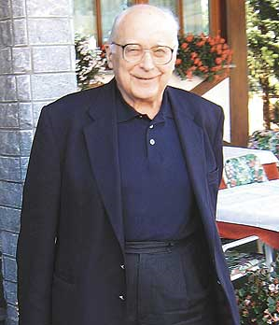
Picture of Ljubo Sirc, Finance, Ljubljana

CRCE Discussion
In March, the boardroom was packed with a distinguished audience. Tomasz Mickiewicz and Philip Hanson spoke on Russia, Poland, Ukraine and the others - some more general lessons from the current crisis. The topic generated much discussion, and there was a lively buzz at this event.

New Publication
A Russian-Slovene Conversation:
Yegor Gaidar and Ljubo Sirc discuss international economic co-operation and other topics

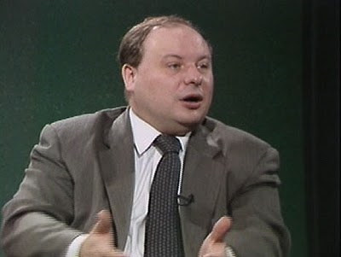
Yegor Gaidar

This is a new edition of an Occasional Paper, originally published 10 years ago to celebrate Ljubo Sirc’s 80th birthday, published in memory of Yegor Gaidar, who died last year. Price: £8.50
Credit card orders: info@junepress.com Cash/cheque sales to CRCE.

Post-Communist Economies
Volume 22, issue 1 now available with articles on Russia, Belarus, Albania and Croatia and Czech Republic.
For a sample copy contact CRCE or:
www.tandf.co.uk/journals

Website
New CRCE Briefing Paper: From Social Democracy to Liberal Socialism: A Property Rights Analysis of the Transition in Europe by Svetozar Pejovich.
Print edition available from the CRCE office. Price: £7.50

The CRCE Newsletter
©2010 CRCE

