The CRCE Newsletter
No. 34 Spring 2009
57 Tufton Street, London SW1P 3QL Tel/fax: +44 (0) 20 7233 1050
email: crce@trident-net.co.uk website: www.crce.org.uk

Prague Declaration on European Conscience and Communism
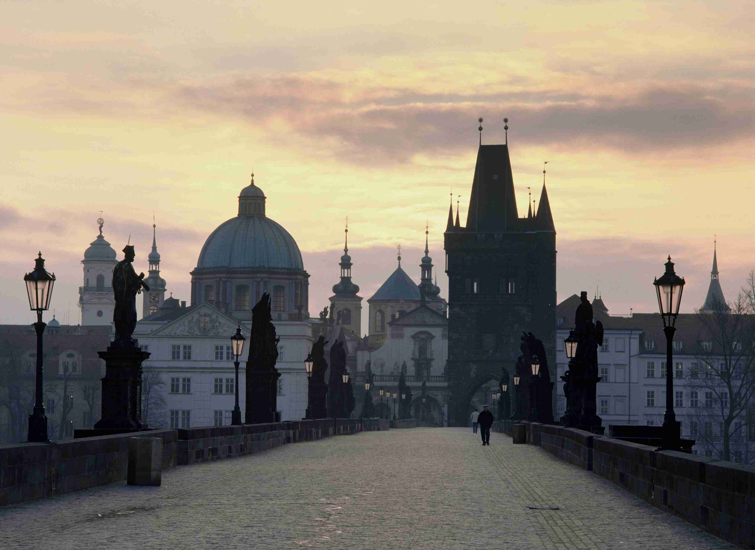

A most important event took place in Prague on June 3rd, 2008, when the Senate of the Parliament of the Czech Republic initiated this declaration. Please sign at http://praguedeclaration.org/

Below are some of the Declaration’s points:

Bearing in mind the dignified and democratic future of our European home,
- whereas societies that neglect the past have no future,
- whereas Europe will not be united unless it is able to reunite its history, recognize Communism and Nazism as a common legacy and bring about an honest and thorough debate on all the totalitarian crimes of the past century,
- whereas the Communist ideology is directly responsible for crimes against humanity,
- whereas a bad conscience stemming from the Communist past is a heavy burden for the future of Europe and for our children,

Keith Miles OBE
The CRCE is pleased to announce that Keith Miles has joined the Advisory Council. We have known Keith for many years from the time he was Financial Director at the IEA. He and his wife Slava have always taken an interest in the CRCE’s work. Keith assisted us in transporting books for last year’s Liberty Camp and organised the London visit of Dr Joze Dezman, Director of the Museum of Contemporary History in Ljubljana.

Tomek Mickiewicz
We are delighted that CRCE trustee Tomek Mickiewicz has been given a Chair at the School of Slavonic Studies, UCL. His inaugural lecture From Lenin to Schumpeter was enjoyed by Philip Hanson, Elena Zhuravskaya, Krystian & Magda Dziekanski. Krystian maintains the Centre’s website and Magda is based at the IEA. We were fascinated to learn that Tomek had once been Deputy Mayor of Lublin, Poland. He began his career in that city's Catholic University.

CRCE News Round-up
Ljubo and Susan Sirc flew to Brussels in November for the International Leaders' Summit organised by the Adriatic Institute at which Ljubo gave an address.

Lisl Biggs-Davison was at the European Bank of Reconstruction and Development (EBRD) for the launch of their annual Transition Report. She was delighted to see Chris Cviic, as its formerly of the Bank's Chief Economist’s Department.

Elena Zhuravskaya visited London in the New Year for Tomek Mickiewicz’s lecture at the School of Slavonic Studies
She is now working at Moscow’s Institute for Financial Studies. CRCE organised a lunch for her at which Professor Philip Hanson was the host.

The New Cold War: Bleak Fact, Double Standard or Paranoid Fantasy- The CRCE and the Centre for Policy Studies invited Edward Lucas of The Economist to talk about his book. At the beginning of the year Edward had launched the first edition at a CRCE meeting. Both events were extremely popular and brought in large audiences.

Gia Jandieri from Georgia visited in December. Last summer he kept us informed when Russia invaded South Ossetia. In the Autumn his conference in Tbilisi, was attended by many CRCE friends. During his stay we arranged meetings for him at Chatham House, the Foreign Office and Shadow Foreign Secretary's office.

Dmitri Trenin of the Carnegie Moscow Centre gave a talk in London on Toughness as Tactics: Assessing Russia’s Approach to International Affairs, which Lisl Biggs-Davison attended.

CRCE Talk on Russia
In March the boardroom was packed for a discussion led by Alena Ledeneva on How Russia Works. She is Professor of Russian Politics and Society at SSEES, and teaches on Russian Domestic Politics, Informal Practices and Corruption. Alena is author of Russia's Economy of Favours. Philip Hanson chaired the meeting

Post-Communist Economies
The journal is in its 21st year, and the Spring Issue is available with articles on:

What beyond oil and gas? Russian trade specialisation in manufacture

Duration of trade of former communist countries in the EU market

Does the balance of payments constrain economic growth? Some evidence for the new EU members

Why is the Polish farm sector still so underdeveloped?

Can Party-led trade unions represent their members?

Industrial agglomeration and labour productivity in transition: an empirical study of Chinese manufacturing industries

Determinants of technical efficiency of Slovenian farms

For a sample copy contact CRCE or:
www.tandf.co.uk/journals

Congratulations
Lydia and Bernard Brscic on their new daughter, Berenika, and also to Magda and Krystian Dziekanski on Agatha's recent arrival.

The CRCE Newsletter is published by
Centre for Research into Post-communist Economies
57 Tufton Street, London, SW1P
©2009 CRCE

Image of the Charles Bridge and skyline of Prague

