The CRCE Newsletter
No. 31 Winter 2007/08
57 Tufton Street, London SW1P 3QL tel/fax: +44 (0) 20 7233 1050
email: crce@trident-net.co.uk website: www.crce.org.uk

CRCE Meetings

In November, Philip Hanson took the Chair when Alex Petersen spoke on: Security and Western Integration in the Caucasus. Alex was doing research at the IISS at the time. He is working for a PhD in International relations at the LSE.

Our last talk of 2007 took place on St Nicholas Day with the intriguing title of "Communism and Vampires" given by our friend Charles Crawford CMG. This was his last engagement before leaving the Foreign Office after 28 years, where he specialised on 'transition' questions in South Africa and across former communist Europe. He spent five years promoting democracy in Russia and across the former Soviet Union and then served as British Ambassador to Sarajevo, Belgrade and Warsaw. We were delighted to welcome Charles, an old friend of the CRCE. Ljubo and Lisl have happy memories of a lunch with him at home in Moscow.

Charles was also instrumental in assisting CRCE with donations of books to universities in Belgrade and Sarajevo when Ambassador in those cities. He is a great loss to the Foreign & Commonwealth Office. Christopher Cviic another friend of Charles took the Chair.

The Travels of Ljubo Sirc
On the 10th October, Ljubo and Sue Sirc attended the International Leaders Summit, Brussels where 'The Future of Transatlantic Relations' was discussed.

Roger Helmer, MEP, reported:
Usually when I need a political fix, a total immersion in liberty and free markets and low taxes and limited government, I go to Washington. You certainly don’t see too much of those concepts in Brussels. But this week we brought conservative values to the heart of darkness, in the European parliament. With my friend and colleague Syed Kamall MEP (London), I co-hosted a Conference in Brussels, which attracted heavyweight conservative minds from across the water. We had Bridgett Wagner and Peter Brookes from Heritage Foundation, Tom Palmer and Dan Mitchell from Cato, Ruth Lea and Sara Rainwater of Global Vision and Mart Laar among others. The organisers were Joel Anand Samy and Natasha Srdoc of the Adriatic Institute.

In November, Ljubo Sirc gave a toast to Freedom at the Atlas Foundation’s Freedom Dinner in Washington. During his stay he had talks with Lee Edwards of the Victims of Communism Memorial.

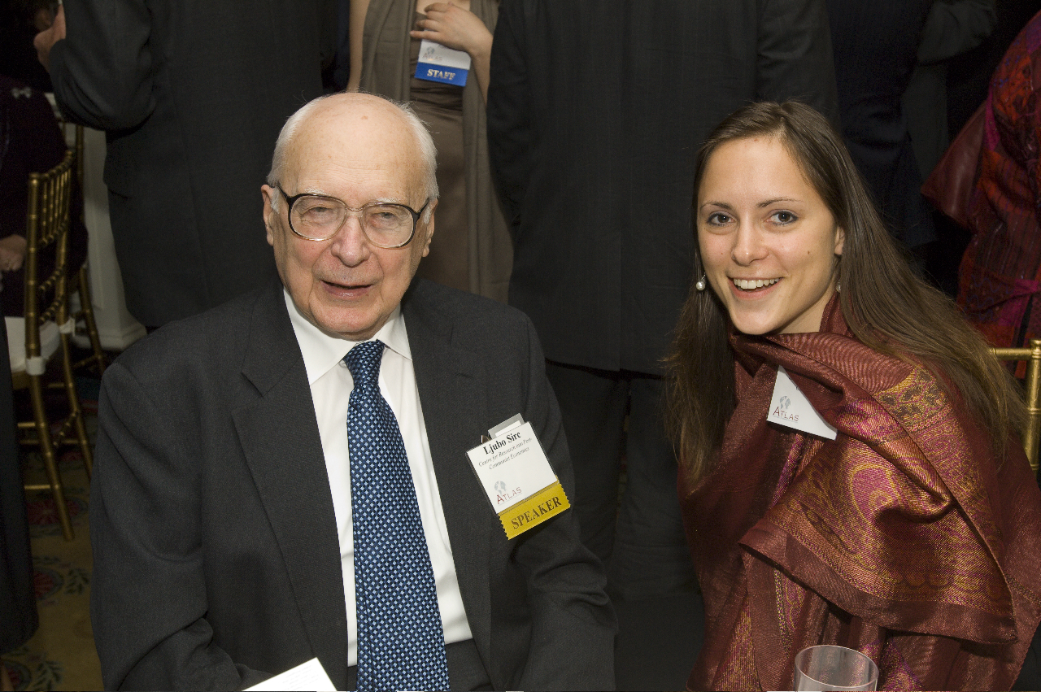

Ljubo Sirc and Tanja Stumberger at the Freedom Dinner.

At the end of November, Ljubo was in Brussels again, invited by Franco Frattini, Vice President of the European Commission, to take part in a high-level seminar: "How to Deal with Totalitarian Memory of Europe: Victims and Reconciliation".

Publications
Two new briefing papers at £7.50 each:

The Economic Situation in Russia before the Parliamentary Election by Elena Zhuravskaya

Security and Western Integration in the Caucasus
by Alexandros Petersen

Russia’s Near Abroad
By Helen Szamuely, Research Fellow CRCE

When the East European countries in various ways threw off the Communist regimes, their immediate aim as far as foreign policy was concerned was to “rejoin Europe”. In actual fact, this did not mean an immediate desire to be part of the European Union. What they wanted was membership of NATO and some kind of a free-trading agreement with west European countries, their greatest fear being that the Soviet Union or, after its collapse, Russia might think of reinvading. As things stand, that is an unlikely scenario. Russia may still be one of the largest arms producers in the world but that is used largely to bring badly needed income into the country. The military forces are in something of a mess: still a call-up army, it nevertheless badly under-recruits year after year, partly because of the low birth-rate that has been Russia’s problem for several generations and partly because anyone who can avoids the nominally compulsory service; its performance in Chechnya has been lamentable, though historically Russia has never done very well against guerrillas; and its own equipment remains less than cutting edge. The latest issue of the Eurasia Daily Monitor, produced by the Jamestown Foundation, talks of the Georgian President Mikheil Saakashvili deciding on modern Western military equipment for the small regular force, leaving the old Soviet era stock for the reserves. “Modern U.S. and Israeli equipment and arms are being procured, in some cases giving the Georgians capabilities the unreformed Russian forces do not have, like intelligence-gathering drones.” Those East European and former Soviet states that have joined NATO have also started rearming with Western weaponry, which may well put them ahead of the Russian forces, should it ever come to that.

That is the negative reason why there will not be a military show-down between Russia and Eastern Europe in the foreseeable future. The other reason is that Russia has found or thinks it has found a different way of pressurizing its erstwhile colonies – economically. Apart from the many Russian firms, all of who have to pay obeisance to the government or end up like Mikhail Khodorkovsky or Boris Berezovsky have done (one in labour camp, one in exile under a permanent guard) that invest or take over business in Eastern Europe, there is the big question of energy supplies, on which these countries rely to a lesser or greater degree.

Relying on Russia for energy would not be a problem if one could be certain that economic rather than political considerations were uppermost in the Russian government’s calculations. The nastiness of its government would not really matter as most oil and gas producing countries leave something to be desired in the democracy stakes. But Russia is special. The easing out of western oil and gas companies may have made short-term political but little long-term economic sense.

Similarly, the supply of cheap energy to supporters in Ukraine and Belarus, with prices suddenly raised when those countries show signs of recalcitrance and supplies cut off as a threat of worse to come, indicate that the old thinking of politics above economics has not died.

Russia’s aim in dealing with the European Union, for instance, appears to be an intention to drive a wedge between the older, western members and the newer, eastern ones. The Russo-German pipeline that is planned to run under the Baltic Sea and has encountered a number of political obstacles, will, if it is ever completed, bypass Poland and the Baltic States and will, these countries fear, enable Russia to control their own supply of energy without affecting Western Europe, thus making it easier for her to put pressure on them.

There are other forms of pressure Russia has tried to exert on former Soviet and East European states, though only in the case of Georgia has there been any military involvement. Most of them centred on the Russian population in those countries where it is sizeable and on the attempts to “re-write” or correct historical accounts of the Second World War with a more accurate description of what went on as the Soviet Army rolled westwards. So far, none of these attempts to exert pressure or stir up trouble has resolved itself in Russia’s favour, so it is likely that the future will see slightly fewer of them and a greater reliance on economic pressure, whether it will mean playing around with supply and pricing of energy or refusal to buy certain products as the recent ban placed on Polish meat and meat products.

The question remains whether the European Union, having taken the former Communist countries in as members instead of negotiating trading agreements, will stand up to Russian pressure on their behalf.

This article first appeared in Eye on Europe, Stockholm Network.

CRCE Newsletter © 2008 CRCE

