The CRCE Newsletter
No. 28 Spring 2007
57 Tufton Street, London SW1P 3QL tel/fax: +44 (0) 20 7233 1050
email: crce@trident-net.co.uk website: www.crce.org.uk

News
The CRCE is pleased to announce that Tomasz Mickiewicz of the School of Slavonic & European Studies, University College London, has joined the Board of Trustees. Dr Mickiewicz is an associate of long-standing and also serves on the editorial board of Post-Communist Economies

Visitors
At the end of January, the CRCE invited Oleg Manaev to London. Professor Manaev is a founder and director of the Independent Institute of Socio-Economic & Political Studies in Belarus. IISEPS revealed a huge gap between real and official results during a 2004 national referendum, which contributed to the organisation being shut down by the Supreme Court. International organisations and Western embassies registered their protests and they continue to support Professor Manaev and his colleagues. The institute is now registered in Lithuania and its activities were vividly demonstrated in Prof. Manaev’s presentation at the CRCE. He was also the guest speaker at a lunch at the Centre.

The CRCE arranged for Professor Manaev to give seminars at Chatham House and the Centre for Russian and East European Studies, University of Birmingham. He also visited Cambridge with Ian Redding where he met and dined with the Master and Fellows of Downing College, Ian’s alma mater. We are grateful for the assistance and support of the British Embassy in Minsk with the organisation of this visit.

The following week, Gia Jandieri of Georgia’s New Economic School in Tbilisi paid a second visit to the Centre. The CRCE assisted in arranging meetings at other institutes and with politicians. He remains optimistic about reform in Georgia, and is pleased Mart Laar is advising the government.

We were pleased to supply Mr Jandieri with a large collection of CRCE publications for the New Economic School

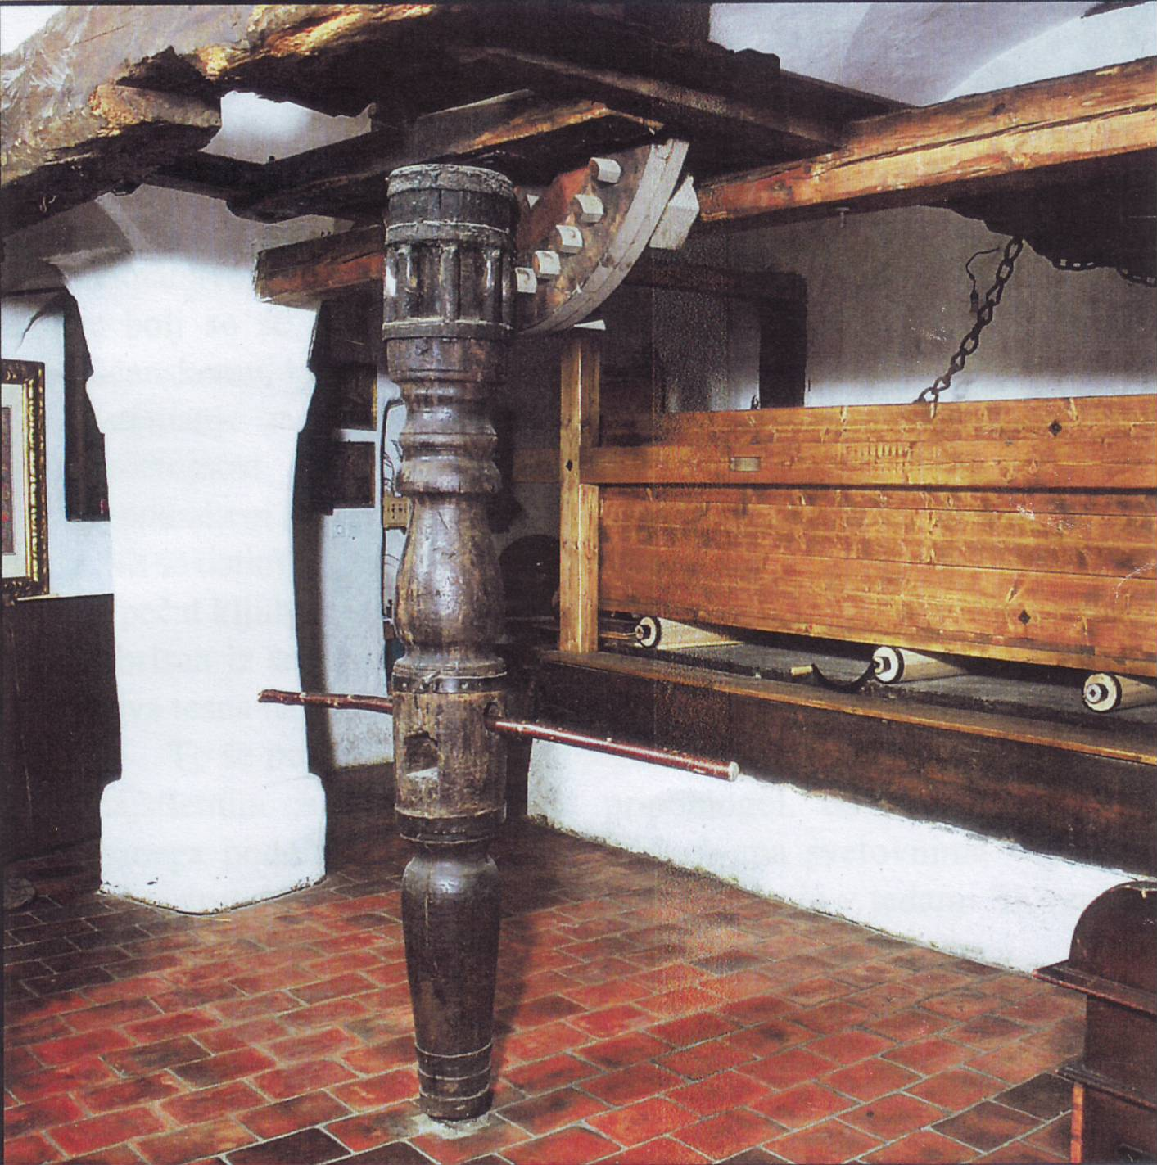

The Monga – a device for ironing fabric – in the Pirc family house, Kranj - see over for story.

CRCE Meetings
Russia 2007: More Neo-Soviet than Post-Soviet
On 22nd February, Martin Dewhirst - a Fellow of the University of Glasgow and Russia watcher - addressed the CRCE on the current political climate in Russia. He has been an OSCE election observer nine times in the former Soviet Union. Many audience members took part in the ensuing discussion. Edward Lucas of The Economist was in the Chair.

Western Broadcasting in the Cold War and After: is it worth it?
Elisabeth Robson, former head of the BBC’s Russian Service, spoke of her experiences on 8th March. Christopher Cviic was in the Chair. The talk included discussion of historic successes and failures, as well as challenges for the present.

We plan to publish Briefing Papers of both meetings.

Lord Harris of High Cross
On 20th February, a multitude of friends filled St. John’s, Smith Square for a marvellous afternoon organised by the IEA in tribute to the late Ralph Harris.

In his address Lord Vinson mentioned the CRCE and Ralph's interest and involvement from the very start. Pascal Salin, friend and colleague who has attended CRCE conferences, also gave an address. I was delighted to see Henri Lepage, another friend from France, Many years ago he, Ralph, Ljubo and I were in Moscow together opening an institute with Egor Gaidar. Henri and I enjoyed reminiscing and remembering how very cold we were! Ralph is to plunge into the queues outside shops and stalls to see what the poor Muscovites were patiently waiting to buy. There was not very much!

Lady Thatcher was among the guests this event, and took part in a photo-call with wearers of colourful waistcoats, worn in tribute to Lord Harris – a great afficionado of this particular garment. Ralph also had some fascinating hats. I was pleased to have the opportunity to chat to Lady Thatcher's assistant, Mark Worthington. The following day Lady Thatcher was in the House of Commons for the unveiling of her statue. L.B-D

Publications
Belarus and Russia Today by Oleg Manaev is now available as a CRCE Briefing Paper at £7.50. Readers can buy the paper at the discounted price of £5.

The first issue of volume 19 of Post-Communist Economies has been published. It carries articles on: the political dimension fiscal policy in Hungary; technological change for Russian agriculture; investment behaviour of Russian farms; economic "clusters" in East Germany; hardened budget constraints in Romania; and the under-use of arbitration in post-communist South-Eastern Europe. For more information contact the editorial office at the CRCE, or visit the Taylor & Francis website: www.tandf.co.uk/journals

Other News

A Visit to the OECD

Ian Redding visited Paris recently, and Bill Tompson, a member of the CRCE Journal Editorial Board, was kind enough to meet Ian and to talk about the OECD, where he is based.

Gas OPEC of the Future?
Ian attended a talk at the IEA given by a former Vice-President of Yukos, who spoke on the inevitability and result of the formation of a gas cartel.

The Monga
When in Slovenia for CRCE conferences, I have often visited Ljubo's cousin Darja Okorn (nee Pirc), and have observed the progress of the restoration of the Monga. Recently, Darja produced a leaflet for visitors, The Pirc Family and their Dye works and we have taken the opportunity to translate this into English for the many friends interested in the history of Ljubo's family. Copies can be accessed on the website or available by post.

The dye-works, started in the early 18th century, which developed and successfully established itself as one of Slovenia’s medium-sized businesses in the mid-19th century. Linen and cotton were dyed, with orders coming from throughout the Austro-Hungarian Empire. Wool products were also dyed, and bought by local farmers.

The mangle (Monga in Slovene) – a 15-foot long oak box (see photo) - was used to iron the dried fabrics. In order for the weight of the box to flatten and straighten the material, it was moved back and forth across the cylinders with the help of a mechanical device, powered either by animals or people. LB-D

The CRCE Newsletter is published by the Centre for Research into Post-communist Economies.
57 Tufton Street, London, SW1P 3QL , UK
©2007 CRCE

