The CRCE Newsletter
No. 27 Winter 2006/2007
57 Tufton Street, London SW1P 3QL tel/fax: +44 (0) 20 7233 1050
email: crce@trident-net.co.uk website: www.crce.org.uk

CRCE Talks

The Hungarian Uprising: Fifty Years On
In October the 50th anniversary of the Hungarian uprising was marred by demonstrations against the present government. Analytical reports of the distressing events were received from Katharine and Sebestyén Gorka and also from our distinguished friend Geza Jeszenszky, former Foreign Minister and also an ambassador to Washington. We were particularly pleased that Sebestyén visited London a week and next week to talk at the CRCE. Sebestyen added a personal element to the discussion, remembering his father's imprisonment and then escape. This was later recounted in Paul Gorka's book, "Budapest betrayed", published by Nicholas Hagger's Oak Tree Books and launched at the House of Commons with Sir John Biggs-Davison MP as Host and the Rt Hon Julian Amery MP as guest speaker. I should like to pay tribute to Nicholas Hagger for publishing important titles ignored by larger publishers. Both Sebestyén and I were present at another Oak Tree Book launch and loaded trucks together for Poland in the 1980s, but we never really met until five years ago!

In his talk Sebestyén mentions the House of Terror Museum in Budapest, formerly the secret police headquarters. In 2003, ITDIS and the CRCE held a conference in Budapest and I took several participants around the museum, which was the most uncomfortable and at times a very distressing experience. However we should be grateful to those who created the museum, as it is far too easy to forget the brutality of communism albeit its recent part of our history. Sebestyén remarked that he is now teaching students who had no idea there were two Germanies until 1989.The museum has a room dedicated to Cardinal Jozsef Mindszenty, who was spoken of at another meeting on Hungary at Policy Exchange. Former ambassador to Budapest, Peter Unwin, recounted that his son had been christened by the Cardinal in the American Embassy, where he lived for 15 years. I wondered then how many in the audience had heard of this remarkable priest. As Ian Redding and I put this Newsletter together we received an article from Helen Szamuely on Raoul Wallenberg, the Swedish diplomat, who saved so many Hungarian Jews from the Nazis, but was taken prisoner by the Red Army and thence to the Lubyanka and Lefortovo Prison. There were persistent rumours that he was seen in the Gulag camps. (LB-D)

Further reading:
The Hungarian Uprising: 50 years On by Sebestyen v. Gorka, with a note on the European Liaison Group by George Ross - see: Publications
The Valiant Shepherd - Joseph Cardinal Mindszenty, 1892-1975 by Kevin Grant, (Aid to Church in Need) free photocopies available from the CRCE.
A Tragic Anniversary by Helen Szamuely (www.Eureferendum.blogspot.com)
Budapest Betrayed by Paul v. Gorka (Oak Tree Books) photocopies available at £10 from CRCE
Radio Free Europe and the Pursuit of Democracy -- My War within the Cold War
by George R. Urban (Yale University Press) George urban was director of Radio Free Europe in Munich for many years, and later a trustee of the CRCE.

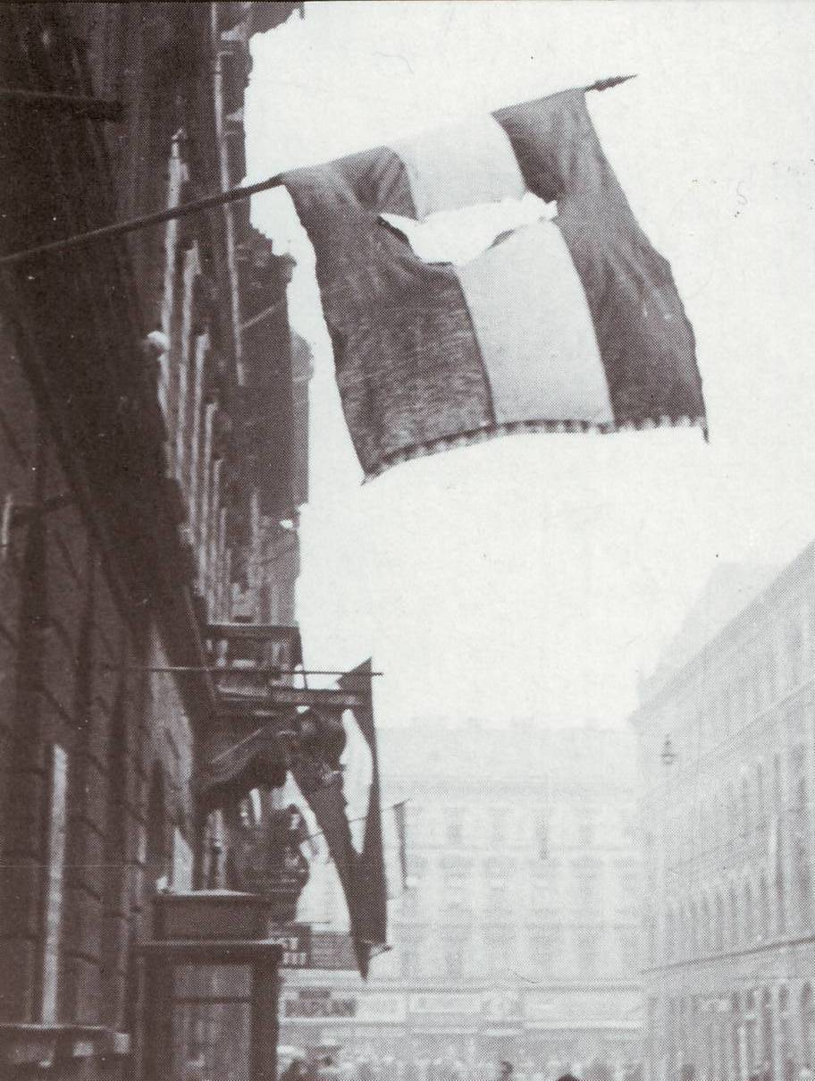
A Conversation with Ljubo Sirc, a Liberty Fund video, part of the Intellectual Portrait Series, of the interview between Dr Sirc and Professor Philip Hanson, was shown as part of the CRCE’s Christmas event. The screening proved particularly interesting to the younger followers of Sirc’s life and work. Documents and photographs from the Sirc family archives were effectively used in the film to illustrate the momentous events in Ljubo Sirc's life.

Antony Fisher Lifetime Achievement Award
In November John Raybould flew in from Canada to receive this award at the Institute of Economic Affairs from Alex Chafuen, President of the Atlas Foundation. It was an extremely happy occasion, and I was fortunate enough to be invited and met many old friends once again. John was of invaluable help to me in the early days at the CRCE, where he taught me so much about publishing.
John wrote on 2nd November to me, " It is a great honour, especially as I worked so closely with Antony, first at the Fraser in the 1970s and then at the IEA in the 1980s. I'm glad I was in at the beginning of CRCE with Ralph and Ljubo. I Emailed Mike Fisher yesterday and he sent me his lovely eulogy to Ralph that he delivered at Ralph's funeral at Barnet today. I first met Ralph in about 1975 when we were setting up the Fraser Institute with Pat Boyle, Antony Fisher and Mike Walker. It will be strange to know that Ralph and Arthur [Seldon] will not be there but their immense legacies live on, don't they, in so many ways." (LB-D)

Outside Meetings
Ian Redding travelled to Brussels where he represented the CRCE at the Libertas Debate Croatian public policy reform organised by the Adriatic Institute for Public Policy, held in the European Parliament. The panel included representatives of the Croatian Government, Opposition and the EU. The Economist’s Edward Lucas took the chair. It was argued that, whilst reform has been forthcoming, in many areas it has been only superficial. The value of pressure from the EU, as part of the accession process, was called in question. Corruption and an over-stretched judicial system continue to hinder much-needed progress. With elections due later this year, there is little hope for an immediate increase in the speed of reform

In December Natasha Srdoc and Joel Anand-Samy, of the Adriatic Institute, were in London to take part in meetings. Ljubo Sirc travelled to London and invited both to lunch and discussions.
Ian Redding attended a seminar and lunch organised by the International Policy Network where they spoke on Croatian Reform, and he and Lisl Biggs-Davison took part in an Open Europe event, where Natasha and Joel debated with the Bulgarian, Romanian and Croatian Ambassadors to London about reforms encouraged by EU accession.

Elsewhere, a seminar about the impact of Russia’s new NGO law on Russian and UK NGOs – held under the Chatham House Rule – did not prove reassuring. The regulations increase the cost and conditionality of operating legally in Russia, and will force many NGOs to discontinue their work. (IR)

January and February at the CRCE
Professor Oleg Manaev from Minsk visited the CRCE. He is Director of the Independent Institute of Socio-Economics and Political Studies. Prof Manaev spoke at a CRCE lunch and also at an evening meeting in January.

Martin Dewhirst, Honorary Research Fellow at the University of Glasgow, will speak on: “Russia 2007: More Neo-Soviet than Post-Soviet? On Thursday 22nd February. Contact office or visit website for details.

Publications
The Hungarian Uprising: Fifty Years On by Sebestyen v Gorka is now available as a CRCE Briefing Paper at £7.50. Readers can buy the paper at the discounted price of £5.

Post-Communist Economies, December issue, is available now, with articles on Russia, Bulgaria, Estonia, Czech Republic and Slovenia.

We are pleased to have been invited to nominate Post-Communist Economies for the 2007 Sir Antony Fisher International Memorial Awards.

