The CRCE Newsletter
No. 26 Autumn 2006
57 Tufton Street, London SW1P 3QL tel/fax: +44 (0) 20 7233 1050
email: crce@trident-net.co.uk website: www.crce.org.uk

Lord Harris of High Cross, 1924 -2006
Tributes to our Founding Trustee are overleaf.

Bled Colloquium
John Moore opened the CRCE’s 2006 conference, “The Problems for Post-Communist Countries in the Context of the European Union”. Guests from a dozen countries attended. (by I Redding, CRCE)

Professor Victoria Curzon Price led a discussion on the “Scope for further privatisation in Old Europe with lessons for New Europe”.

Krassen Stanchev of Bulgaria, Tim Congdon of the UK, Raul Eamets of Estonia and Jan Winiecki of Poland also acknowledged the importance of the rule of law in the development of successful, prosperous societies.

The final session consisted of progress reports from various countries. Observations of the progress – or lack thereof – were often not the cause of optimism. Matej Kovac of Slovenia, Sebestyén Gorka of Hungary, Miroslav Prokopijevic of Serbia and Natasha Srdoc and Joel Samy of Croatia agreed that reforms in their respective countries were often superficial. Sebestyén concluded the protests in Hungary were the inevitable result of successive governments, unwilling to tackle the fundamental economic. Petr Mach of the Centre for Economics and Politics, Prague, provided a positive conclusion, following his analysis of trends in the Czech economy.
(Report: Ian Redding, Intern, CRCE)

CRCE Talks
Kosovo -- The Road to Independence was the topic of a CRCE talk given by James Pettifer at the Adam Smith Institute, and we were very grateful to the director and staff for their hospitality. James, a specialist on Balkan affairs, brought us up to date with events in Kosovo. The talk was both useful and fascinating.
Sebestyen Gorka, Director of ITDIS, spoke on the Hungarian uprising in 1956, together with the recent events in Budapest – report in next newsletter.

Outside Meetings
Lisl Biggs-Davison attended an IPN briefing by Andrei Illarionov on the future of democracy in Russia, and the implications of the G8 Summit.

Lisl and Helen Szamuely took part in a discussion in July on The Future of Free Speech in Russia with Yevgeny Volk, Chairman of the Hayek Foundation in Moscow. Participants signed a “Statement of Concern for Freedom in Russia”. Ian Redding attended a later meeting on the Russia’s new NGO regulations.

Publications
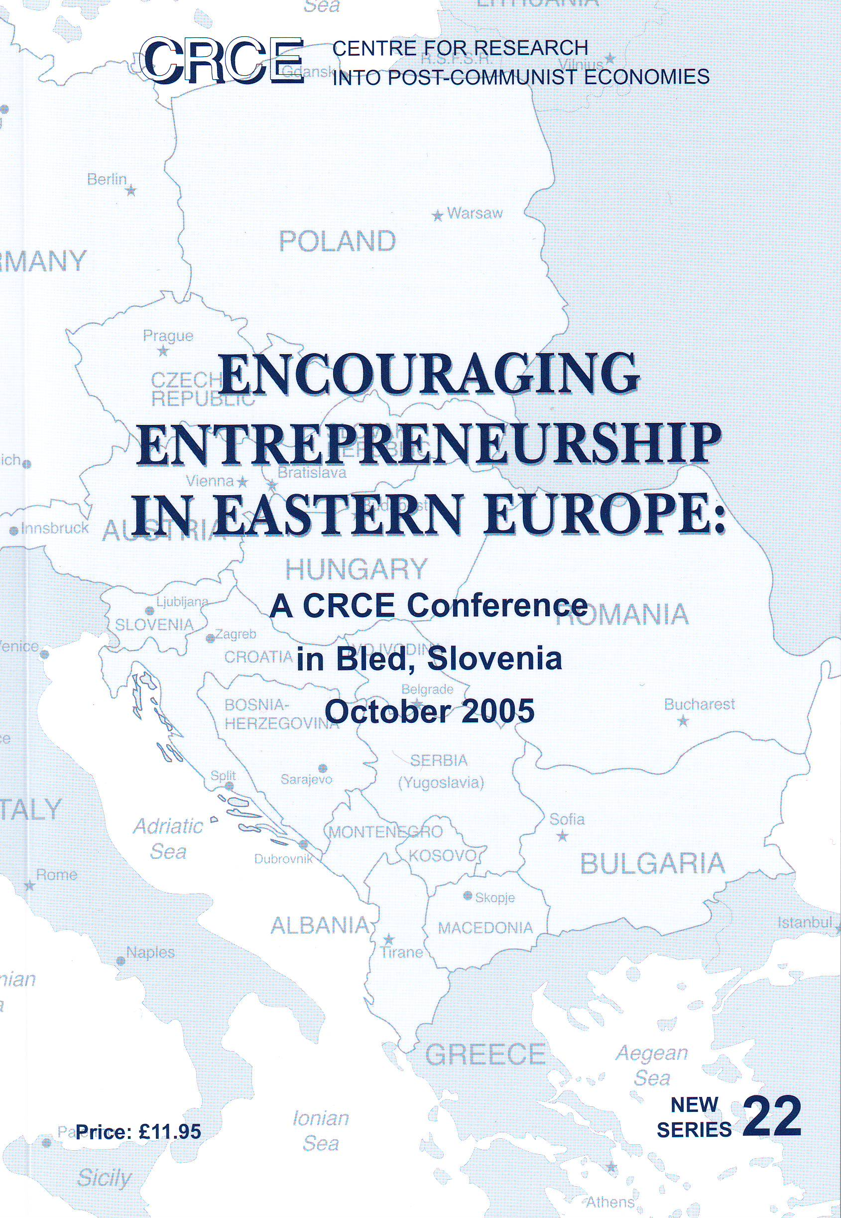
Encouraging Entrepreneurship in Eastern Europe is the latest in our New Series contains papers and discussion from the CRCE Colloquium in Bled last year. Readers can buy the book at a discount at £8.

Post-Communist Economies, September issue, is available now, with articles on Russia, Poland and Vietnam.

We are pleased to welcome to the Editorial Board; Bill Tompson, OECD, Paris; Tomasz Mickiewicz, School of Slavonic and East European Studies, London University; Clifford Gaddy, The Brookings Institution, Washington, DC.

CRCE Interns
Congratulations to both Tom Grieder and Kristin Annexstad for academic achievements! Tom was awarded a First and Kristin a Merit from the LSE. Tom spent time this summer working with disabled children in Moldova. Kristin has travelled within the Ukraine, Hungary and Belarus and is now working in publishing.

Lord Harris of High Cross

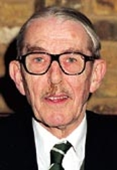

10th December 1924 – 19th October 2006

It is with great sadness that we announce the death of Ralph Harris, founder of the Institute of Economic Affairs, and co-founder of the Centre for Research into Post-Communist Economies. It is 20 years since Ralph asked if I would like to join him and Ljubo Sirc at the IEA and run the CRCE. I had known Ralph since my student days, when he used to speak at the Freedom Association. As meeting secretary I often invited him to address our audiences. I was inspired by Ralph’s enthusiasm and knowledge, and it has been a great privilege to have been associated with him over so many years.

Lord Harris succeeded Sir Antony Fisher as Chairman of Trustees in 1988. Ralph devoted a considerable amount of time and energy in raising money for the Centre and working with Ljubo Sirc and myself. After 1989, he interested several companies in supporting our work, particularly in Russia.

In 1998, Lord Harris initiated a debate on property rights in the House of Lords, with special reference to Ljubo Sirc’s restitution case.

In 1983, Ralph wrote:

"When conflicts between East and West are fraught with such momentous dangers, international understanding may be the only alternative to mutual destruction.

"All the more timely is the establishment of the Centre for Research into Communist Economies. Its single-minded aim is to educate the public by research into the economic policies of countries with communist governments.

"In a world so beset by prejudice based on rival propaganda and ignorance, the centre has a vital role to play in spreading knowledge based on research and education."

In 1990, Lord and Lady Harris visited Russia in company with Ljubo Sirc, and encouraged the young reformers, who then took on the vexing task of government. Lord Harris took a major part in conferences (including one of the earlier meetings in Bled) with our Russian and East European friends over the years.

We shall miss him so much.

Lisl Biggs Davison

Tributes by other CRCE friends will be provided on request. © CRCE 2006

