The CRCE Newsletter
No. 23 Autumn/Winter 2005
57 Tufton Street, London SW1P 3QL; tel (+44) 020 7233 1050; fax (+44) 020 7222 4299
email: crce@crce.freewire.co.uk website: www.crce.org.uk

Colloquium in Slovenia
Once again the Centre held its annual conference on the shores of Lake Bled in Slovenia. The colloquium was in honour of Andrzej Brzeski, which was most appropriate as he was the inspiration behind this series of meetings.
We should like to express our gratitude to the Earhart Foundation for sponsoring the colloquium.
During the meeting, Ljubo Sirc was interviewed by Radio Free Europe and also by the Slovene newspaper, Finance.

London Seminar
An important meeting examining the position of Europe a year after NATO and EU enlargement took place in the London office. Sebestyen Gorka from ITDIS, flew in from Budapest to take part along with Richard North and Helen Szamuely. A CRCE Briefing based on the discussion is available. See Publications below.

Mart Laar and the Flat Tax
The Sunday Telegraph, (September 4, 2005) ran an article under the heading:
Pioneer of the ‘flat tax’ taught to the East to thrive - headstrong Estonian leader adopted radical regime after reading only one economics book.
The leader in question of course is our friend Mart Laar. In October 2002, Mart, Lady Thatcher and the late Sir Denis Thatcher, were guests of honour at the launch of ‘Estonia: Little Country That Could’ published by the CRCE. This last year has seen a great interest in flat tax in countries such as Croatia and Slovenia. A dozen copies of Mart's CRCE book were dispatched to New York recently to the Atlas Economic Research Foundation’s 2005 Freedom Dinner, where Mart Laar delivered the keynote address. The event marked the 16th anniversary of the fall of the Berlin Wall, a date that is now celebrated as World Freedom Day in 20 countries. There has been a renewed interest in ‘Estonia: Little Country That Could’ from countries such as Slovenia. The CRCE is therefore offering the book at a special price to Newsletter readers.
Of further interest The Economist of 15th October published an article comparing Estonia and Slovenia. The Slovenian Prime Minister is quoted:
‘Slovenia wants Estonian style growth. The current rate, a projected 3.9% this year, will not match West European levels fast enough. Worse, other post communist countries are catching up.’ ‘We are losing our first place,’ says the Prime Minister, Janez Jansa. He blames the gradualist approach of past governments. Having just returned from the Baltic States, he speaks of Estonia as ‘a good example for us’.
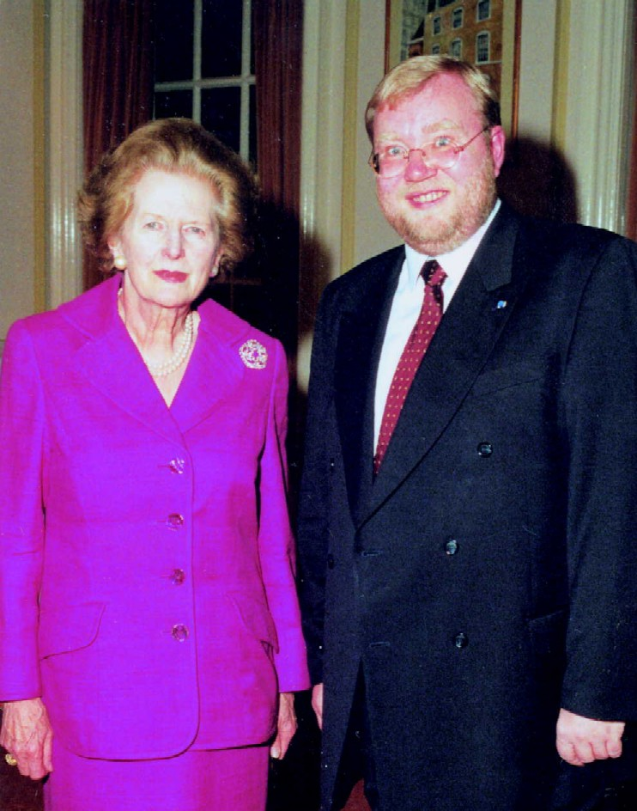
I am delighted to publish our photograph again of Lady Thatcher and Mart Laar taken at the book launch three years ago. It provides the opportunity for marking Lady Thatcher’s 80th birthday this year.
The Adriatic Institute for Public Policy has published a book on flat tax for Croatia:
‘It’s also important to remember that a lot of positive action on the tax front is going on in Europe. Soon the taxpayers of Croatia will have a handy guide to a flat tax. The book, Flat Tax: The Case for Tax Reform in Croatia, will be released next Wednesday and will then go on an across-Croatia tour. Besides the numerous European scholars and policymakers who contributed, the book features an introduction by Heritage’s Dan Mitchell and the Hoover Institution’s Alvin Rabushka. The leading authors are Joel Anand Samy and Natasha Srdoc, of the Adriatic Institute. The book comes out November 9th, with a translation coming later in the month for us Anglophones. (Insider, Heritage Foundation, October 2005.)
Joel and Natasha participated in the Bled colloquium this September.

Publications
New Briefing Paper: How the East was Won: What Next for NATO and the EU One Year after in Enlargement? based on the CRCE seminar with contributions from Sebestyen Gorka, Richard North & Helen Szamuely. Price, £10 including postage.
Estonia: Little Country That Could by Mart Laar (CRCE, 2002) is available from the office at the special price of £10/$25 (including postage).
Post-Communist Economies:
The September issue is now available and includes articles on Russia, Poland, Slovenia and the Czech Republic. Inspection copies are available on request, and more details about the Journal can be found on: www.tandf.co.uk/journals.

Obituaries
Arthur Seldon, Co-Founder of the IEA, died on the 11th October. In my early days at the CRCE, based at the IEA, I was frequently asked to help Arthur Seldon with his photocopying; because my desk was by the photocopier! He was delightful, and I enjoyed our chats as the machine trundled out the copies. Arthur’s parents had been born in Russia, and he was always interested in the work of the CRCE. When we ran a writing and journalism course for young Russians, Arthur was an enthusiastic teacher. John Raybould wrote from Canada, to tell me that Hayek had appreciated Arthur’s tough editing. Find out more on: www.arthurseldon.org. We send most sincere condolences to his family

Edward Szczepanik, who died on the same day, was a member of our Advisory Council. He was the last prime minister of the Polish government in Exile, which kept a lonely vigil in London for Poland’s independence during the 45 years of Soviet rule. In 1991 he returned to his home country where he was awarded the Grand Order of the Rebirth of Poland. Copies of an interesting obituary in the Daily Telegraph are available from this office. We extend our sympathy to his wife and family.

The CRCE Newsletter is published by the Centre for Research into Post-Communist Economies. © 2005 CRCE.

